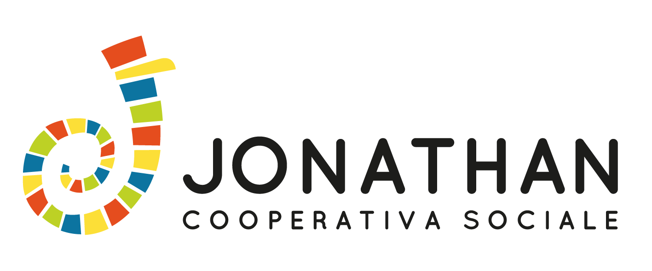
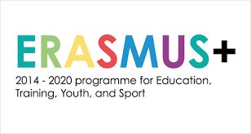
Participant Application Form
‘Women & Peace’ Youth Exchange
Name
Family name
Date and place of birth
Full address
(street, city, post code,..)
E-mail address
Facebook contact
Personal phone/mobile
And communication apps (whatsapp, viber,..)
Dietary Requirements and Special Needs
(Food, disability, allergies, vegetarian, etc.)
Health information
(diseases, illness, etc.)
Emergency Contact Person (name,surname,phone nr., E-mail, relationship)
English and Spanish level (Basic/Good/Fluent)

Did you have any international/mobility experiences ?

Why are you interested in the topic of the project?

Shortly describe your motivation and expectations to take part in this youth exchange

Other experience that you think might be relevant

