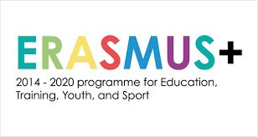
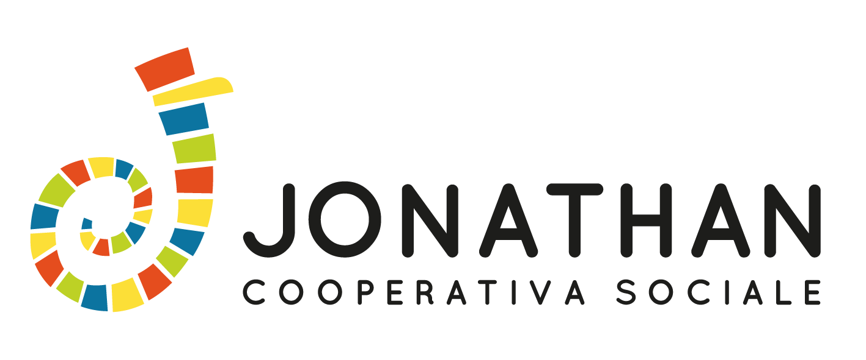

Team Leader Application Form
‘Women & Peace’ Youth Exchange
Name
Family name
Date and place of birth
Full address
(street, city, post code,..)
E-mail address
Facebook contact
Personal phone/mobile
And communication apps (whatsapp, viber,..)
Dietary Requirements and Special Needs
(Food, disability, allergies, vegetarian, etc.)
Health information
(diseases, illness, etc.)
Emergency Contact Person (name,surname,phone nr., E-mail, relationship)
English and Spanish level (Basic/Good/Fluent)

Did you have any experiences before as team leader? Please, shortly describe them (if any).

Did you have any experiences in intercultural learning and non-formal learning? Please, shortly describe them (if any).
Did you have any international/mobility experiences ?

Why are you interested in the topic of the project?

Other experience that you think might be relevant

