
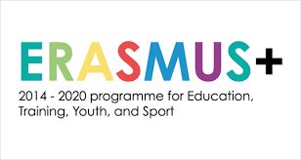
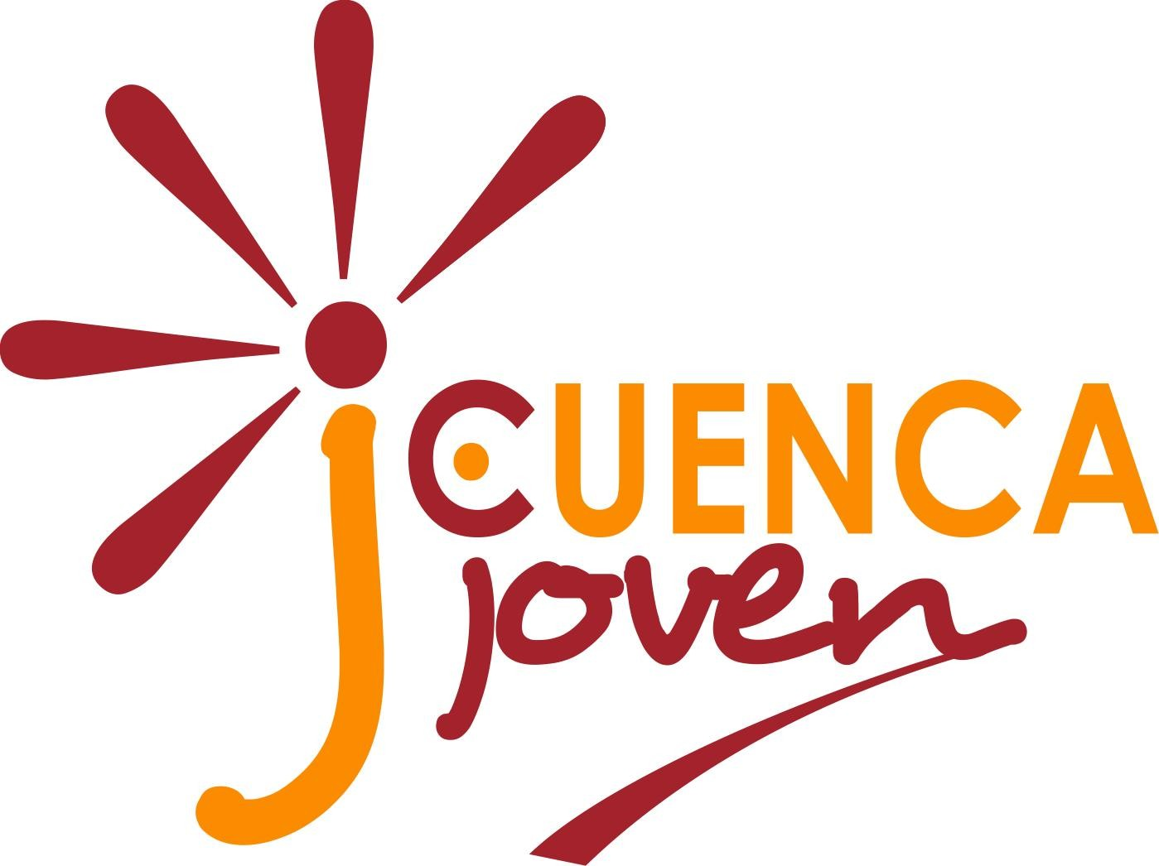

Participant Application Form

Name
Surname
Gender
Date of Birth
Nationality and Country of Residency
E-mail
Phone nr.
ID/Passport nr.
Emergency Contact Person (write down name,surname,address,phone nr. E-mail, relationship)

English level (Basic/Good/Fluent)

Shortly describe your experience in projects connected to intercultural learning (if any)

What are your previous International/mobility experiences?

Are you interested in the topic of the project? Why?

Shortly describe your motivation and expectations to take part in this youth exchange

Are you willing to take part in some project activities before and after the youth exchange? (the project foresees 4 pre- and post-departure meetings per country group and 1 local event after the exchange).

Other experience that you think might be relevant

Any special dietary needs? Food Intolerance? Or special health condition?

Any requests or recommendations?

- I hereby declare that I have carefully had entirely read and understood the Project Description.
- I hereby commit myself to participate in the whole process of this project.
- I hereby accepted to pay extra cost if my travel ticket exceed the amount established by the European Commission.
- I am aware that the insurance is my own or my organization’s responsibility.
- I understand that the information I have provided on my special needs does not remove my own personal responsibility for ensuring my own health.
- I hereby declare that everything stated in the present form corresponds to the truth.

